Initial Range: 30-70 F

Which season?

New Range: 30 – 50 F

Answer = Winter

Historical average?

New Range: 40 – 50 F

Answer = 46

Max temp today?

Final Prediction = 44 F

Answer = 43

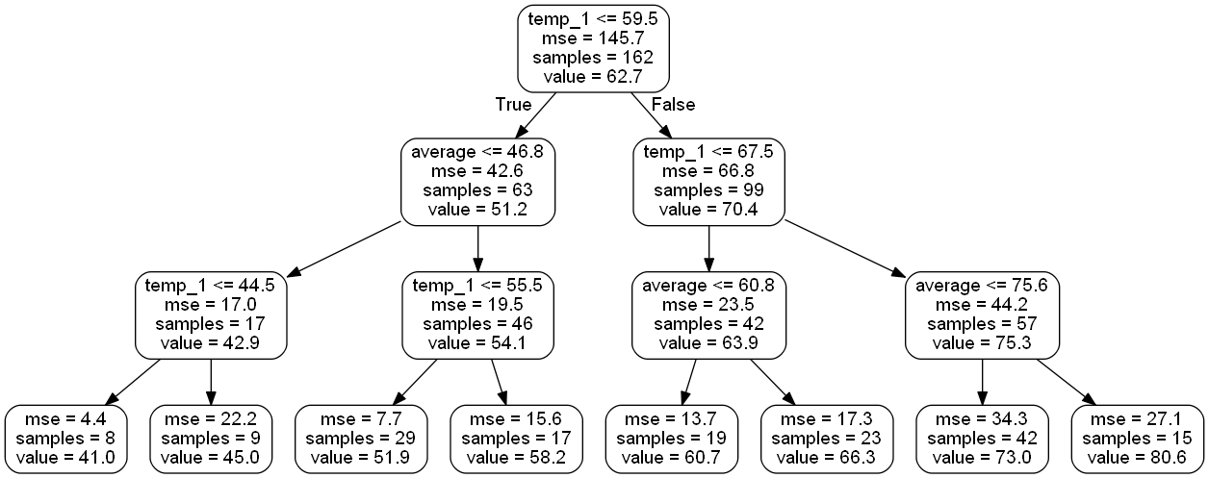

**Root Node**

Variable and Value to split Node on

Number of data points in this node

Prediction (in degrees) for all data points in node

Mean Squared Error of Node

**Leaf Nodes**

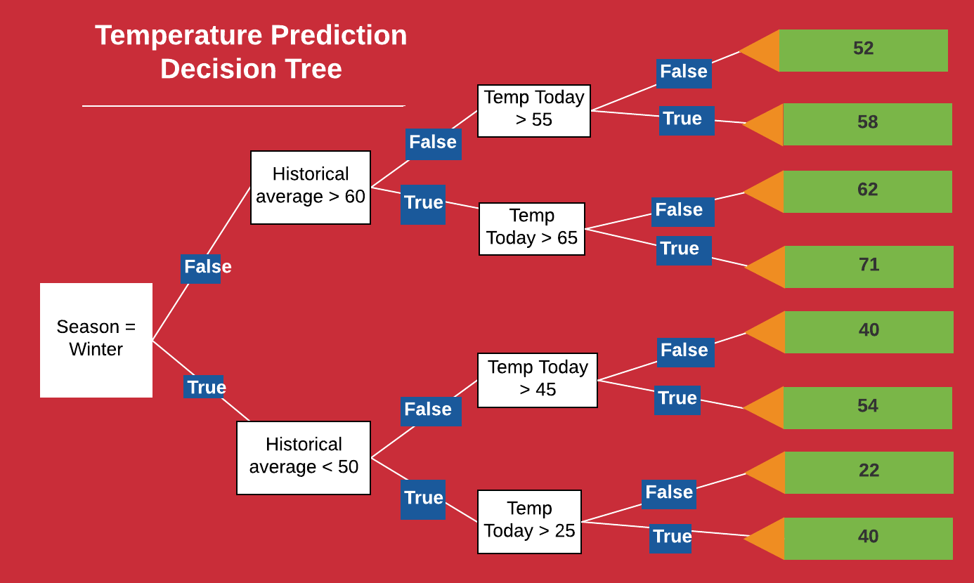

**Predictions**